LAB # 11

ImplementING uninformed search techniquies

# OBJECTIVE

Finding shortest path using BFS and DFS search technique in python.

**Lab Tasks:**

1. Apply Breadth First Search on following graph considering the initial state is A and final state is G. Show results in form of open and closed list.

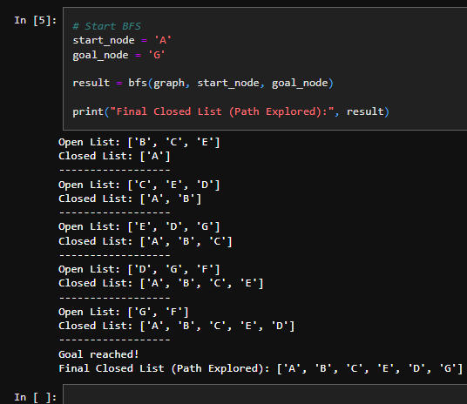**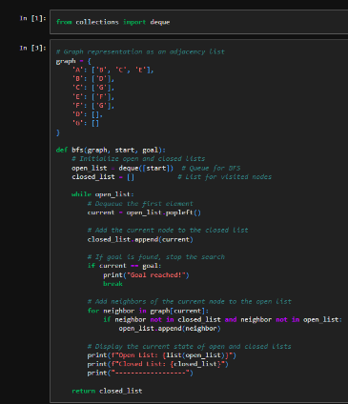Code:**

1. Using Question no. 1 apply BFS by taking initial and final state as user input. Show results in form of open and closed list.

**Code:**

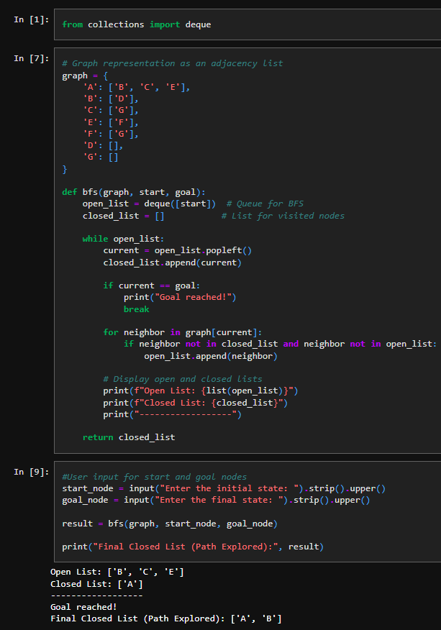

1. Apply Depth First Search on the graph given in question 1. Considering the initial state is A and final state is G. Show results in form of open and closed list.

**Code:**

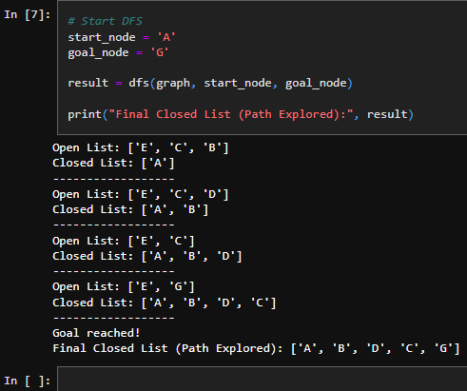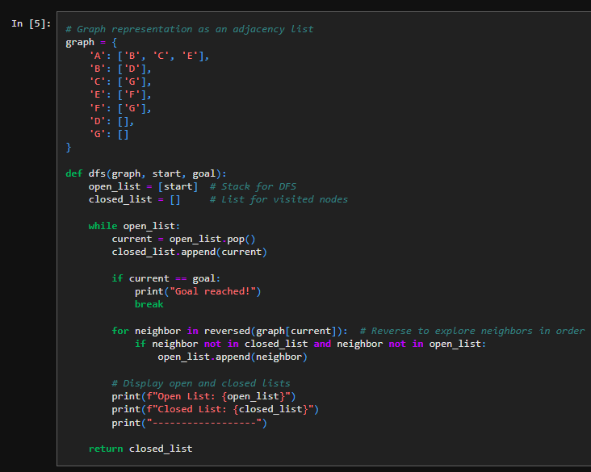

1. Using Question no. 1 apply DFS by taking initial and final state as user input. Show results in form of open and closed list.

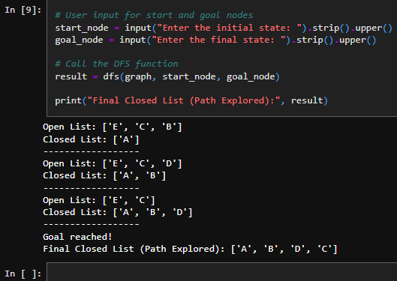**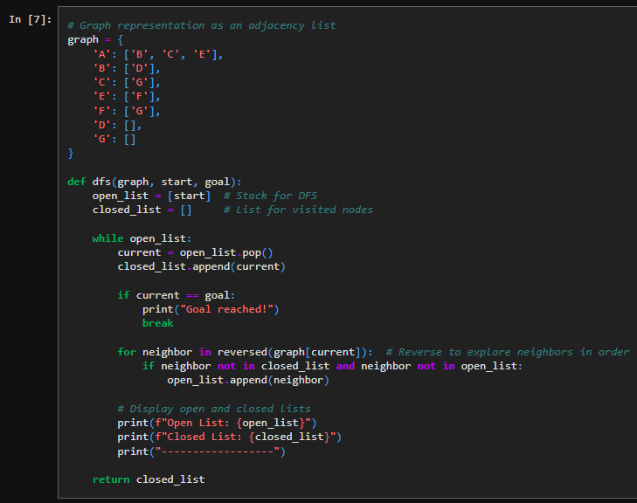Code:**